EOG Review: Ratios Unpacked Questions Name: _________________________ Block: _________
- There are 15 fish in your fish tank. The number of guppies is represented by black circles and the number of goldfish is represented by white circles.
- What is the ratio of guppies to goldfish?

- What is the ratio of goldfish to guppies?

- What is the ratio of guppies to total fish?

- If a ratio looks like an improper fraction, can it be turned into a mixed number? Why or why not?

2. There are 2 cookies for 3 students. What is the amount of cookie each student would receive? (i.e. the unit rate)

3. On a bicycle Jack can travel 20 miles in 4 hours. What are the unit rates in this situation?
a. What is the distance Jack can travel in 1 hour? b. What is the amount of time required to travel 1 mile?

4. At Books Unlimited, 3 paperback books cost $18.
a. What would 7 books cost? b. How many books could be purchased with $54?

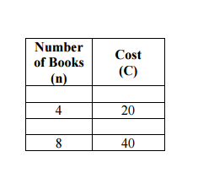
5. Another bookstore offers paperback books at the prices below. Which bookstore has the best buy? Explain your answer.

6. The ratio of cups of orange juice concentrate to cups of water in punch is 1: 3. If James made 32 cups of punch, how many cups of orange did he need? Use a chart to help you solve.

7. Using the information in the table, find the number of baskets for 24 apples.
Apples | 3 | 6 | 9 | 15 | 24
Baskets | 1 | 2 | 3 | 5 | ?

8. Compare the number of black circles to white circles. If the ratio remains the same, what values will complete the table?

Black | 4 |  | 20 | 60
White | 3 | 30 |  |  | 60

9. In trail mix, the ratio of cups of peanuts to cups of chocolate candies is 3 to 2.
a. How many cups of chocolate candies would be needed for 9 cups of peanuts?

b. How many cups of chocolate candies would be needed for 1 cup of peanuts?

c. How many cups of chocolate candies would be needed for 10 cups of trail mix?

10. If steak costs $2.25 per pound, how much does 0.8 pounds of steak cost?

11. What percent is 12 out of 25? 12. What is 40% of 30? 13. 6 is 30% of what number?

14. If 30% of the students in Mrs. Rutherford’s class like chocolate ice cream, then how many students are in Mrs. Rutherford’s class if 6 like chocolate ice cream?

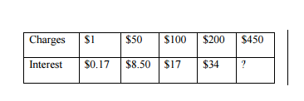
15. A credit card company charges 17% interest fee on any charges not paid at the end of the month. The ratio table shows how much the interest would be for several amounts. If the bill totals $450 for this month, how much interest would you have to be paid on the balance?

16. How many centimeters are in 7 feet, given that 1inch ≈ 2.54 cm.

