1. | 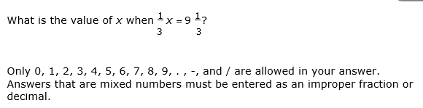  .
2. | Meena has two boxes. The first box weighs pounds. The second box weighs 4 pounds. How much heavier is the second box?
3. | What is the value of x if:  3.5 + x = 8.25
4. | What is the solution to the equation below?  15 + 9 = x(5 + 3)
 | A. 3
 | B. 5
 | C. 12
 | D. 16
5. | Andy runs the same number of miles, x, every day. His total distance run for one week is less than 60 miles. Which inequality represents how many miles Andy runs each day?
 | A. 7 + x > 60
 | B. 7 + x < 60
 | C. 7x > 60
 | D. 7x < 60
6. | .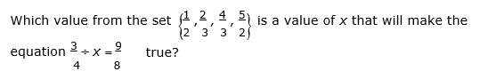
 | A. 1/2
 | B. 2/3
 | C. 4/3
 | D. 5/2
7. | If y = 11, what is the value of z in the equation z + 2 = y?
 | A. 9
 | B. 11
 | C. 13
 | D. 22
8. | In which equation does x = 12?
 | A. 6 + x = 18
 | B. 5 + x = 18
 | C. 4 – x = 8
 | D. 4 – x = 16
9. | Lisa wants to buy a wallet for $29.90, including tax. Which equation can be used to represent how much change, x, Lisa will receive if she pays with a $50 bill?
 | A. x + 50 = 29.90
 | B. x – 50 = 29.90
 | C. x – 29.90 = 50
 | D. x + 29.90 = 50
10. | Tasha bought 5 blueberry pies. All the pies were the same price. She spent $35.75. What equation could be used to find the price of one pie, x?
 | A. x ÷ 5 = 35.75
 | B. 5x = 35.75
 | C. 35.75 + x = 5
 | D. 5 +x= 35.75

11. | Two equations are shown below.  m + 2.2 = 7.3  n – 2.4 = 8.9  Based on the values of m and n, which is correct?
 | A. n < m
 | B. m <n
 | C. n = 6.5
 | D. m = 9.5

12. | The area of a rectangle is 241.92 cm². The length is 19.2 cm. What is the width of this rectangle?
 | A. 12.60 cm
 | B. 12.74 cm
 | C. 101.76 cm
 | D. 111.76 cm
13. | Which graph represents the solution set for x > –3?
 | A.
 | B.
 | C.
 | D.
14. | A class needs at least 65 sandwiches for a picnic. Which inequality represents the number of sandwiches, n, the class needs for the picnic?
 | A. n > 65
 | B. n < 65
 | C. n ≥ 65
 | D. n ≤ 65
15. | Which inequality represents the graph below?  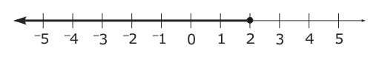
 | A. x > 2
 | B. x < 2
 | C. x ≥ 2
 | D. x ≤ 2
16. | Which set of values would make the inequality 0.35 + p ≤ 1.76 true?
 | A. {1.15, 1.27, 1.45}
 | B. {1.25, 1.31, 1.41}
 | C. {1.41, 1.53, 1.65}
 | D. {2.11, 2.25, 2.42}
17. | Tonya pays $300 each month to rent an office where she earns $25 per hour tutoring students. Which equation represents Tonya’s profit, y, for working x hours?
 | A. y = 25 + 300x
 | B. y = 25x + 300
 | C. y = 25 - 300x
 | D. y = 25x - 300

18. | A school band is selling boxes of fruit. The graph below shows how much the band earns based on the number of boxes they sell.  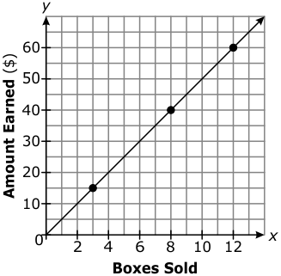  Which equation represents the amount of money the band will earn if they sell x boxes of fruit?
 | A. y = 5 + x
 | B. y = 5x
 | C. y = 10 + x
 | D. y = 10x

