2018 CMS 6th Grade Unit 1 Test [2502271]
Student
Class
Date

1. | What is the area, in square units, of the shaded rhombus shown below?  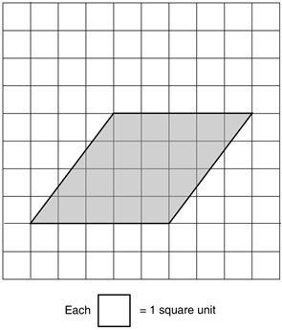

2. | What is the area, in square units, of the shaded triangle shown below?  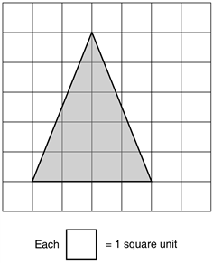

3. | The net of a triangular pyramid is shown. A pyramid will be constructed by this pattern, but it will not have a base.  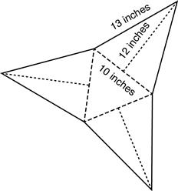  What is the surface area of the faces of the pyramid? Record your answer in square inches.

4. | The net of a rectangular prism is shown.  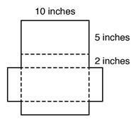  What is the surface area, in square inches, of the figure shown in the net?

5. | Nancy’s toy kite is shown with the side lengths labeled.  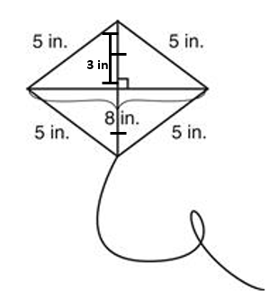  What is the area of her kite?
 | A. 20 square inches |  | B. 24 square inches
 | C. 25 square inches |  | D. 40 square inches

6. | The measurements for the parallelogram are given in meters.  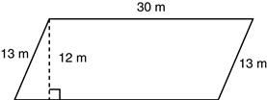  What is the area of this parallelogram, in square meters?
 | A. 360 |  | B. 390
 | C. 516 |  | D. 750

7. | Derek drew a picture of the stop sign shown in this diagram.  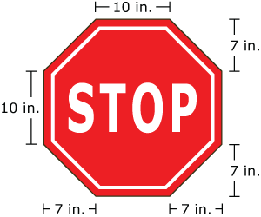  What is the area, in square inches, of Derek’s stop sign?
 | A. 338 |  | B. 380
 | C. 478 |  | D. 576

8. | What is the area of this triangle?  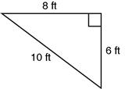
 | A. 24 |  | B. 30
 | C. 40 |  | D. 48

9. | What is the area of the figure below if the measurements shown are in inches?  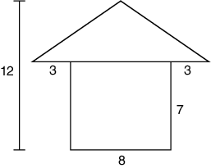
 | A. |  | B.
 | C. |  | D.

10. | What is the area of the triangle with a base measure of 7 inches and a height measure of 12 inches?
 | A. 19 in.² |  | B. 38 in.²
 | C. 42 in.² |  | D. 84 in.²

11. | What is the area of the shaded triangle?  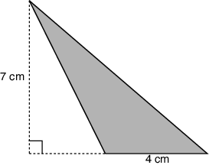
 | A. |  | B.
 | C. |  | D.

12. | If the area of Triangle ABD is 12 square units, what is the area of Rectangle ABCD?
 | A. 6 square units |  | B. 12 square units
 | C. 24 square units |  | D. 48 square units

13. | The net of a square pyramid is shown below.  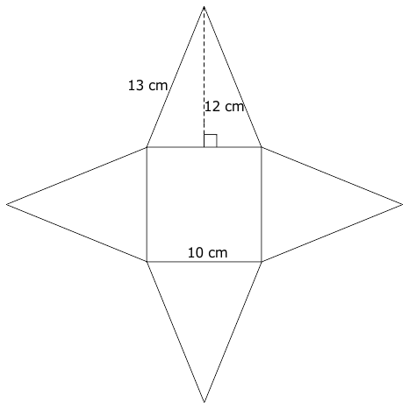  What is the surface area of the square pyramid?
 | A. 240 cm² |  | B. 340 cm²
 | C. 580 cm² |  | D. 780 cm²

14. | What 3-dimensional figure can be created by folding the shape below on the dashed lines?  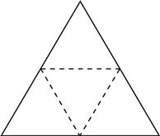
 | A. cube |  | B. prism
 | C. pyramid |  | D. triangle

15. | The net of a cube with a 7-mm side length is shown below.  What is the surface area of the cube?
 | A. 245 mm² |  | B. 252 mm²
 | C. 294 mm² |  | D. 343 mm²

16. | What is the surface area of the triangular prism?  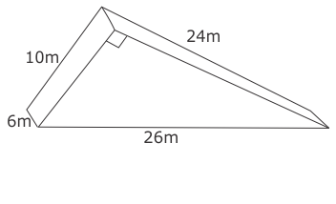
 | A. 1,440 m² |  | B. 840 m²
 | C. 600 m² |  | D. 480 m²

17. | The object below is a triangular prism and its net.  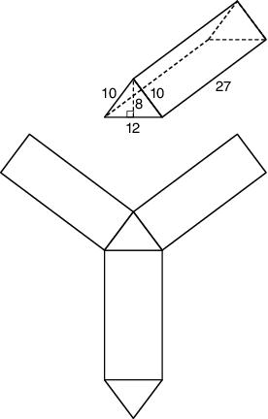  What is the surface area of this triangular prism in square units?
 | A. 906 |  | B. 912
 | C. 960 |  | D. 1,056

18. | A rectangular prism is shown below.  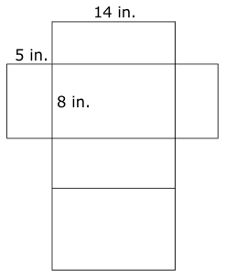  What is the surface area of the rectangular prism?
 | A. 444 in.² |  | B. 528 in.²
 | C. 560 in.²

19. | What 3-dimensional figure can be created by folding the shape shown below on the dotted lines?  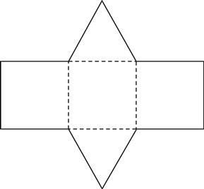
 | A. cube |  | B. prism
 | C. pyramid |  | D. triangle

20. | Mia made a pencil box in the shape of a right rectangular prism.  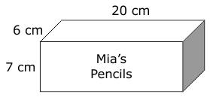  What is the surface area of the box?
 | A. 390 cm² |  | B. 604 cm²
 | C. 840 cm² |  | D. 1,260 cm²

