1. | A box has a base area of 5 square inches and a volume of 82.25 cubic inches. How tall, in inches, is the box?

2. | A certain toy box has dimensions 1 1/2 feet by 2 1/4 feet by 1/4 feet. A company is selling them in bulk, and the shipping box is 48 inches x 3 feet x 5 feet. About how many flash drives can fit in each shipping box?

3. | 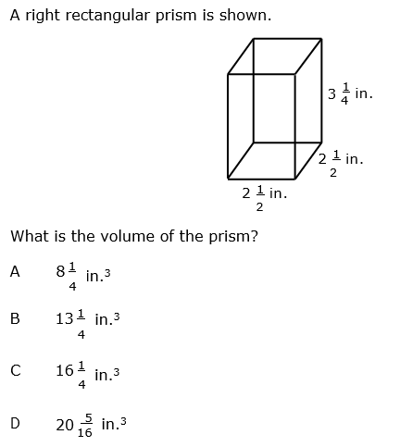

4. | The rectangular prism has 24 cubes. The side  Length of each cube is $\frac{5}{2}$. What is the volume of  Cube?  .
 | A. 24 cubic inches
 | B. 375 cubic inches
 | C. 15.625 cubic inches
 | D. 13,824 cubic inches
5. | 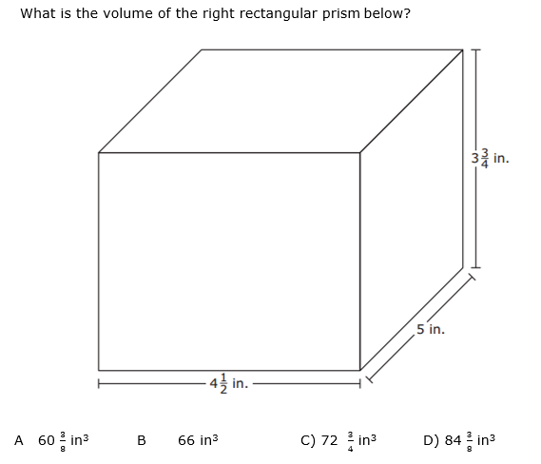
6. A right rectangular prism has edge lengths of 2 $\frac{1}{2}$ inches, 2 inches, and 3 $\frac{3}{4}$ inches. How many cubes with $\frac{1}{4}$–inch edge lengths would be needed to fill the prism completely?
A. 64 B. 18.75 C. 1,200 D. 12
7. | The right rectangular prism below is made up of 12 cubes. The edge of each cube measures $\frac{2}{3}$ cm.  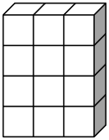  What is the volume of the rectangular prism?
A. 3$\frac{5}{9}$ cm cubed C. 24 cm cubed
B. 12 cm cubed D. 5$\frac{1}{3}$ cm cubed
8. | The side lengths of Cube 1 are$\frac{1}{4}$ inch. The side lengths of Cube 2 are 5 inches.  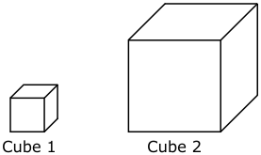  How many Cube 1s would be needed to fill Cube 2?
A. | 512 B. 64 C. 125 D. 8,000
9. | A prism has a square base with a side length of 6 $\frac{1}{2}$ feet. The height of the prism is 8 feet. What is the volume of the prism?
 | A. 52 ft³
 | B. 338 ft³
 | C. 84.5 ft³
 | D. 1.23 ft³
10. | A box in the shape of a rectangular prism has a volume of 425 cm³ and a height of cm. Which choice could be the length and width of the rectangular prism?
 | A. length: 50 cm width: 25 cm
 | B. length: 18 cm width: 10 cm
 | C. length: 10 cm width: 5 cm
 | D. length: 25 cm width: 25 cm
11. | A square prism has a base area of in.² The height of the prism is 6 $\frac{3}{4}$ in.What is the volume of the prism?
 | A. 992 in.³
 | B. 72 in.³
 | C. 1012 $\frac{59}{64}$ in.³
 | D. 82 $\frac{11}{16}$ in.³
12. | A package for number cubes is in the shape of a right rectangular prism. The package holds 3 cubes across, 4 cubes high, and 6 cubes deep. Each edge of each number cube measures $\frac{1}{3}$of an inch. What is the volume of the package?
 | A. 2$\frac{2}{3}$ cubic inches
 | B. 72 cubic inches
 | C. 27 cubic inches
 | D. 1944 cubic inches

